
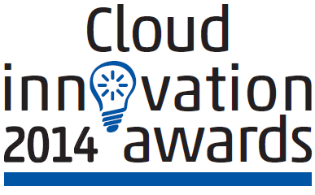


Cloud/Datacenter Solution
Submission Form

Please complete and return this form by March 7th 2014 to katieb@netevents.org or faxback to +44 (0) 870 760 6464.
- Additional material to assist your submission for this award may be included e.g. case studies. In addition, you must stipulate if any information pertaining to the award entry material is under NDA on your award entry submission.
- The Innovation Awards will be presented at the Cloud Innovation Summit’s Evening Celebration on Thursday 27th March 2014 in Los Gatos, California, USA. Individual ticket price: $150; table of 6 ticket price: $750.
- Full award category descriptions are available at: http://www.netevents.org/portfolio/2014-innovation-awards.
Name: ___________________________________________ Position: ________________________________________
Company: ________________________________________________________________________________________
Address: _________________________________________________________________________________________
_________________________________________________________________________________________________
Postcode/Zip: _____________________________ Country: ____________________________________________
Telephone:________________________ Fax:________________________ E-mail: _____________________________

Submission topic: Cloud/Datacenter Solution
Submission outline (200-250 words) to be attached to this entry form – please explain the outstanding achievements of your Cloud/Datacenter Solution which makes your company eligible for this award.

Product/Solution:___________________________________________________________Launch date:______________

Pricing information (if available):________________________________________________________________________
Date of first customer installation: ______________________________________________________________________
1st End user customer reference: _______________________________________________________________________
2nd End user customer reference: ______________________________________________________________________
3rd End user customer reference: ______________________________________________________________________

There is an optional entry fee donation for each award submission of $475, 100% of the award entry fee will be donated to the America Cancer Society and the Prostate Project Foundation.

Please tick the box below if you would like to make a charity donation:
- Yes, I would like to donate $475 USD to the America Cancer Society and Prostate Project Foundation.

After submission you will receive a confirmation email and follow up correspondence for charity donation/tickets for the awards evening if applicable.

